News Zermatt Bergbahnen AG
B2C – Newsletter

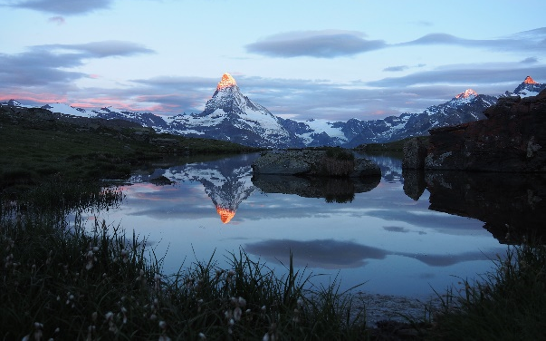 | SUNRISE AT THE LAKE STELLISEE  Early risers will be rewarded! Experience the sunrise at the lake «Stellisee» and enjoy a scrumptious breakfast at the mountain restaurant Fluhalp. Every Saturday until the end of September this offer is available. What are you waiting for? Book the special offer “sunrise at the lake Stellisee” here.
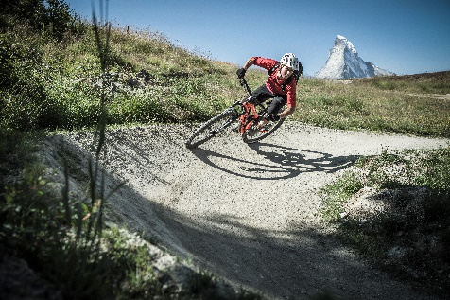 | BIKEPASS LIGHT  With the «Bikepass light» you can enjoy unlimited mountain rides in our cable cars on the following routes:  - Zermatt – Sunnegga – Blauherd  - Zermatt – Furi – Schwarzsee  - Zermatt – Furi – Riffelberg  The «Bikepass light» can be booked for 1 to 6 days and includes the bike transportation in all the according cable cars. Check out our bike-offers here.
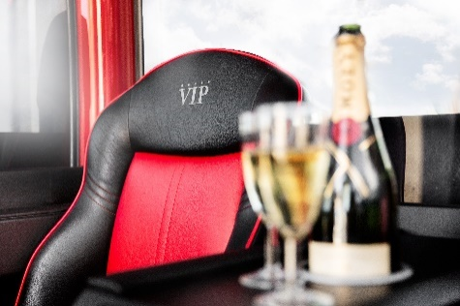 | VIP-GONDEL  You just love the Alps and sometimes want to indulge in something special whilst you are on holidays? In this case, why don’t you treat yourself to the VIP gondola. In comfortable leather seats, sipping a glass of Moët & Chandon champagne, the ride from Zermatt to Trockener Steg can be enjoyed in a unique and spectacular way in summer and in winter. Become our VIP here.
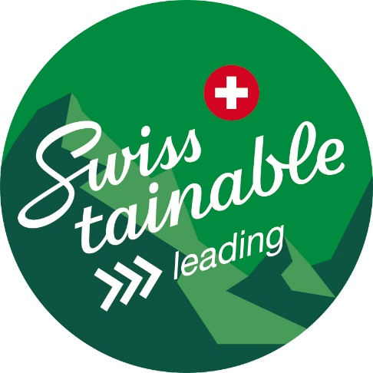 | ZERMATT BERBAHNEN AG GOES SWISSTAINABLE  The Matterhorn Zermatt Bergbahnen have been leading the path for sustainable experiences and operations amongst the Swiss cable car companies for many years. Continuously striving for ways to create a balance between our environmental protection, Corporate Social Responsibility and reaching our goals in terms of growth, Switzerland Tourism has awarded us with the new label “Swisstainable” on level 3 (leading) – the highest possible level. Read more about sustainability at Matterhorn Zermatt Bergbahnen here.
BCB – Newsletter
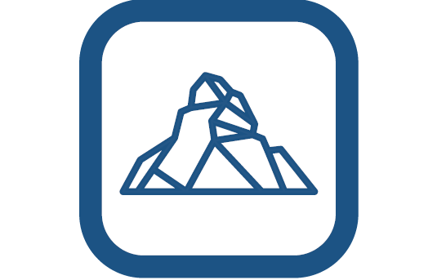 | MATTERHORN PARADISE APP  Thanks to the Matterhorn paradise App, the Matterhorn paradise can now be discovered and experienced in a virtual format. In addition, the app contains all important and up to date information for our B2B partners. Downloading this App is definitely worth it. What are you waiting for?
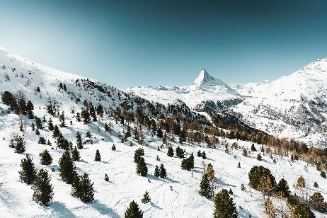 | TRADE WEBSEITE  In an easy and convenient way, our new trade website displays all information about our offers and products to be experienced here, in the Matterhorn paradise and the surrounding mountain world.  Visit our download-site to find our flyers, brochures, photos, and video materials. Thanks to the news feed, you will always be up to date with information about our team and where to meet us. To access the new trade website, click here.
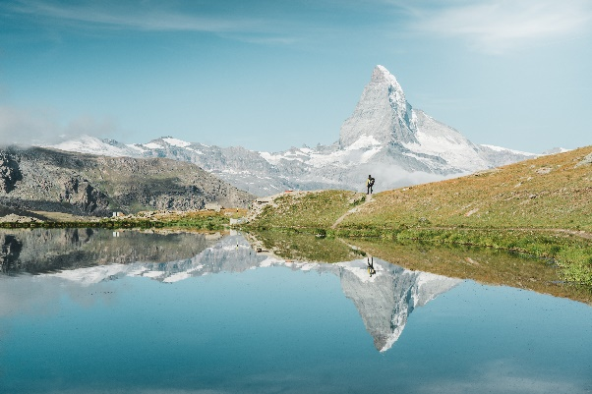 | INSPIRATION MANUAL  Let us inspire you with our products and offers here in the mountain world of the Matterhorn paradise. No matter if you are winter sports enthusiasts, nature lovers or solely fascinated by the Matterhorn – the Matterhorn paradise can be discovered in countless ways. To access the new inspiration manual, click here.
ZERMATT BERBAHNEN AG GOES SWISSTAINABLE

The Matterhorn Zermatt Bergbahnen have been leading the path for sustainable experiences and operations amongst the Swiss cable car companies for many years. Continuously striving for ways to create a balance between our environmental protection, Corporate Social Responsibility and reaching our goals in terms of growth, Switzerland Tourism has awarded us with the new label “Swisstainable” on level 3 (leading) – the highest possible level. Read more about sustainability at Matterhorn Zermatt Bergbahnen here.

