Winter news Zermatt.
Ring in the winter with Winter Celebrations Zermatt
Celebrating winter, celebrating Zermatt. A new series of events under the banner "Winter Celebrations Zermatt" is set to herald the winter season. Visitors and local residents can enjoy a wide-ranging programme at various locations in the four weeks from 17 December 2021 to 17 January 2022. Experience ice and light art in the village and get in the mood for winter.

www.zermatt.ch/en/Media/News/Events/Ring-in-the-winter-with-Winter-Celebrations-Zermatt

Zermatt Unplugged – music comeback in April
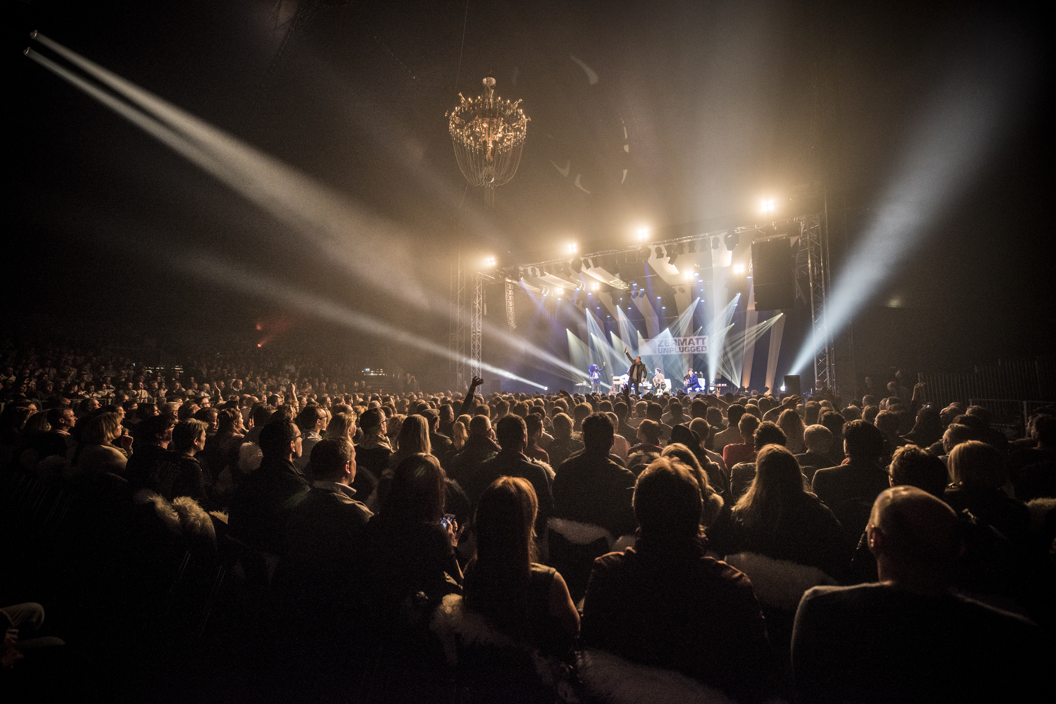
Acoustic music, culinary delights and exciting discoveries: April has it all! From 5 – 9 April 2022, the organisers of the Zermatt Unplugged Music Festival are planning to fill the unique mountain world of Zermatt with delightful musical moments after a two-year break due to the coronavirus pandemic.

www.zermatt.ch/en/Media/News/Events/Zermatt-Unplugged-music-comeback-in-April

Innovative developments at the Cervo Mountain Resort
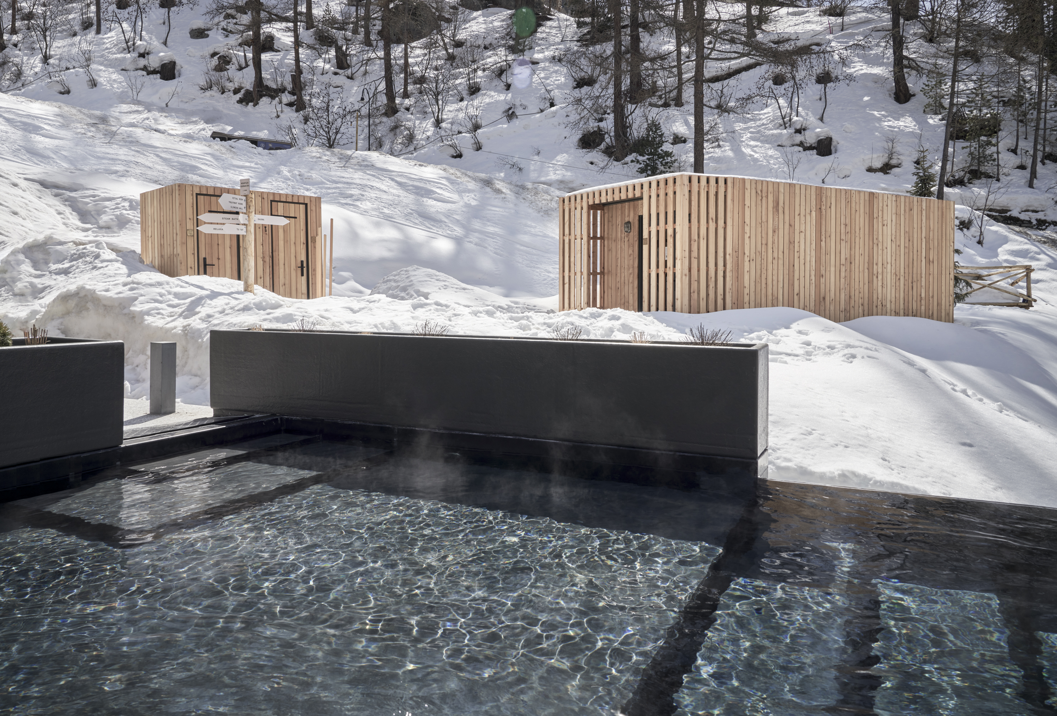
The Cervo Mountain Resort has a host of new developments for the winter season 2021/2022 and the summer season beyond. From its natural swimming pond to macramé workshops and a sound path, the opportunities for guest relaxation just got bigger.

www.zermatt.ch/en/Media/News/Accommodation/Innovative-developments-at-the-Cervo-Mountain-Resort

Grand Hotel Zermatterhof included in Historic Hotels Worldwide
The Grand Hotel Zermatterhof in Zermatt, which has existed since 1879, has been accepted into Historic Hotels Worldwide, the official programme of the National Trust for Historic Preservation to recognise and celebrate the best historic hotels around the world.

www.zermatt.ch/en/Media/News/Accommodation/Grand-Hotel-Zermatterhof-included-in-Historic-Hotels-Worldwide

New Matterhorn Testcenter – skiing at the highest level
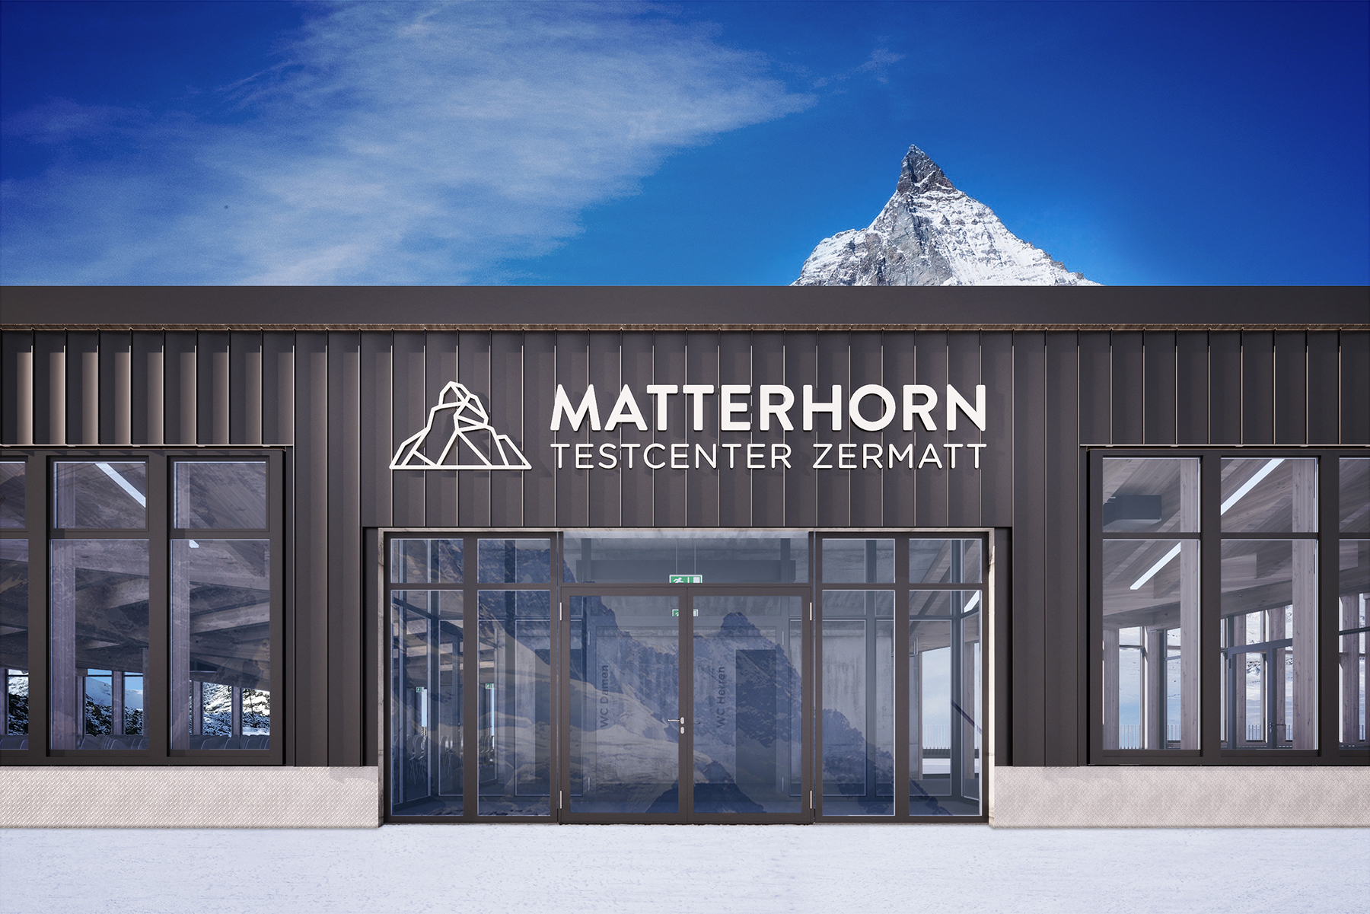
The ski test on the Theodul glacier in Zermatt is among the most beautiful experiences in the high alpine region. In October 2021, the modern and spacious Matterhorn Testcenter will open its doors, offering guests the opportunity to test the latest ski models in a unique setting. A ski-in & ski-out experience in a class of its own!

www.zermatt.ch/en/Media/News/Activities/New-Matterhorn-Testcenter-skiing-at-the-highest-level

Matterhorn Alpine Crossing: the vision becomes a reality
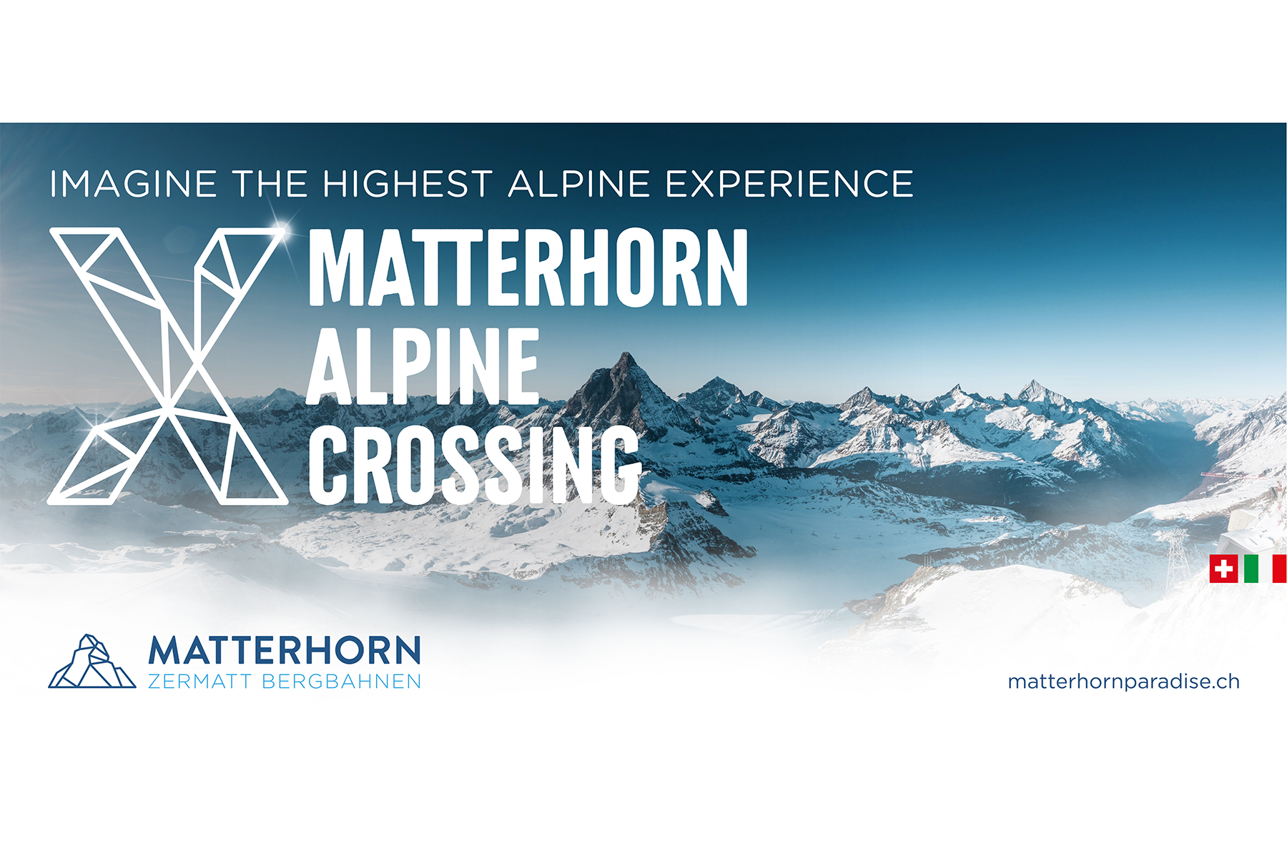
The clock is ticking: it's just one year until the Matterhorn Glacier Ride ll goes into operation. The modern 3S cable car will connect the Klein Matterhorn mountain station at 3,883 metres above sea level with the Testa Grigia valley station in Italy, thus enabling one of the highest and most panoramic border crossings – the Matterhorn Alpine Crossing.

www.zermatt.ch/en/Media/News/Transport/Matterhorn-Alpine-Crossing-the-vision-becomes-a-reality

Kumme gondola lift starts its second winter season
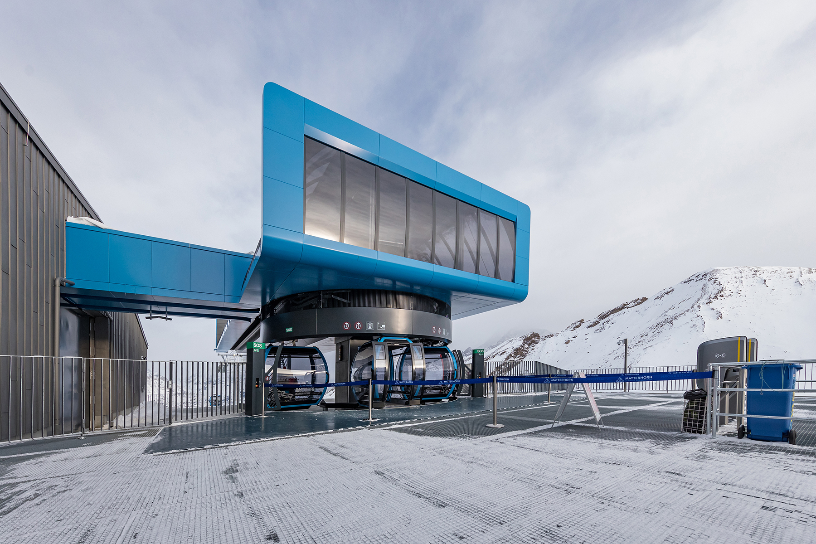
The coronavirus crisis somewhat marred the opening of Switzerland's first autonomous gondola lift last winter. This year, the gondola lift on the Rothorn will start its second season – transporting guests from all over the world from Tufternkehr via the Wyss Gufer middle station to the 3,103-metre-high Rothorn.

www.zermatt.ch/en/Media/News/Transport/Kumme-gondola-lift-starts-its-second-winter-season

