Lucerne – Lake Lucerne Region

News Winter 2021/2022
New Rigi Bahnen rolling stock  Rigi Bahnen’s new generation of railway multiple units was unveiled in autumn 2021. Featuring an elegant colour scheme, the design of the rolling stock is a tribute to the world’s oldest cogwheel railcar, which dates from 1911. Six of the new multiple units are due to enter regular service in spring 2022.  www.rigi.ch | 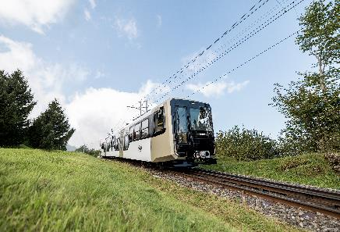
Diving with the submarine  Commencing winter 2021, the Subspirit company is offering unforgettable underwater trips in Lake Lucerne for up to three passengers at a time on board its unique P-63 submarine. Switzerland’s only commercially licensed submarine dives to a depth of 100 metres and offers glimpses of wrecks on the lakebed.  www.subspirit.ch | 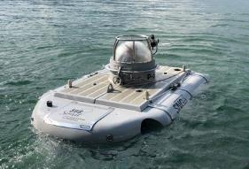
«Red Bull the Edge» at the Swiss Museum of Transport  Climbing to the top of the Matterhorn is a real adventure – and remains a dream for many of us. «Red Bull the Edge» brings visitors to the Swiss Museum of Transport one step closer to this dream. They can now climb the Matterhorn virtually thanks to a visionary concept that combines innovative VR technology with 360° film production techniques.  www.verkehrshaus.ch | 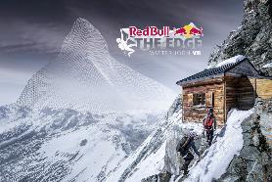
Campus «DAS MORGEN»  The region Weggis Vitznau Rigi is enriched by a unique offer. In March 2022, the Campus DAS MORGEN will open in Vitznau. The Campus combines the Neuro Campus Hotel - a purely digital hotel, three restaurants with different concepts, a unique roof-top lounge and an open marketplace as a meeting place.  www.dasmorgen.ch | 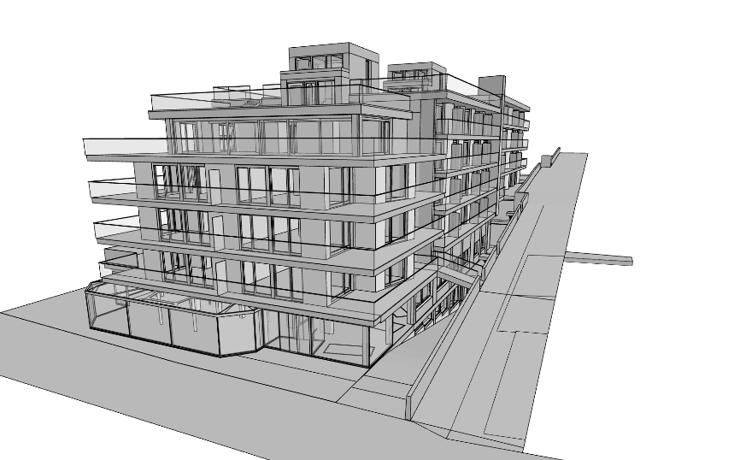
Mandarin Oriental Palace Lucerne  The former Hotel Palace Lucerne has been undergoing extensive renovation since November 2017. The plans include redesigning all 146 guest rooms and suites, the public areas, restaurants and bars, and the grounds. Its reopening as part of the Mandarin Oriental Hotel Group is scheduled for early spring 2022.  www.swissdeluxehotels.com | 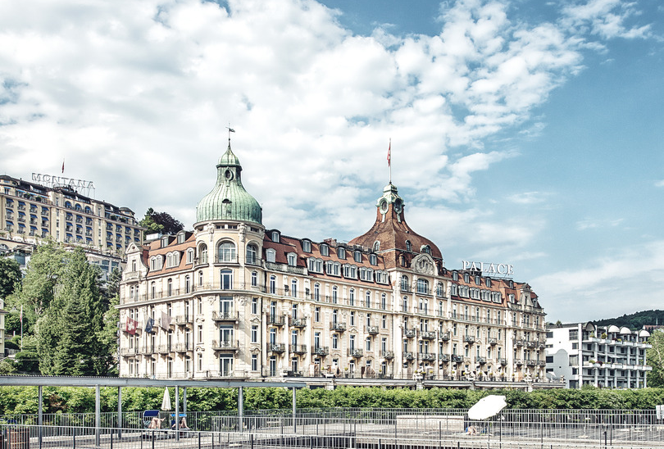
Winteruniversiade Lucerne 2021  From December 11 to 21, 2021, the Lucerne-Lake Lucerne region will host the Winter Universiade 2021. The program includes competitions in ten sports taking place at seven venues. Around 1600 student athletes between the ages of 17 and 25 from more than 500 universities in 58 countries are expected to take part in the event in Switzerland.  www.winteruniversiade2021.ch | 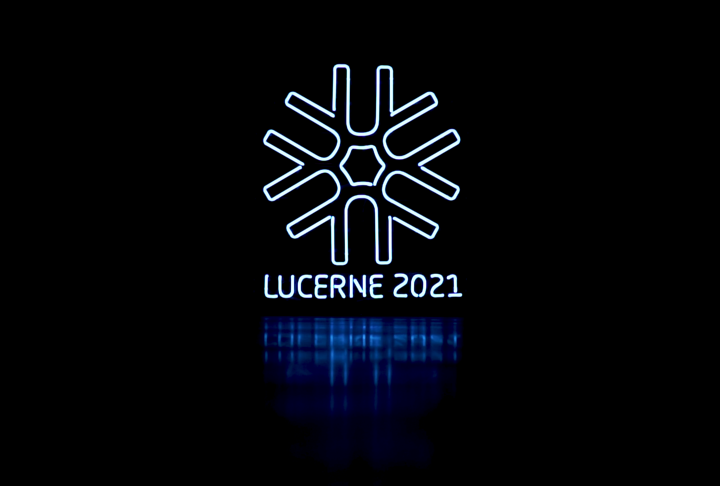
Lilu Light Festival Lucerne  Between 6 and 16 January 2022 Lucerne will again become a gathering place immersed in light! The third edition of the Lilu Light Festival Lucerne finds artists from all over the world showcasing light in all its manifold and fascinating facets. Discover creative light installations on a heart-warming winter walk and experience an attractive side programme designed to appeal to all the senses. For eleven days, the squares, tourist attractions and alleys of the city of Lucerne will be artfully illuminated between 6 and 10 p.m.  www.lichtfestivalluzern.ch | 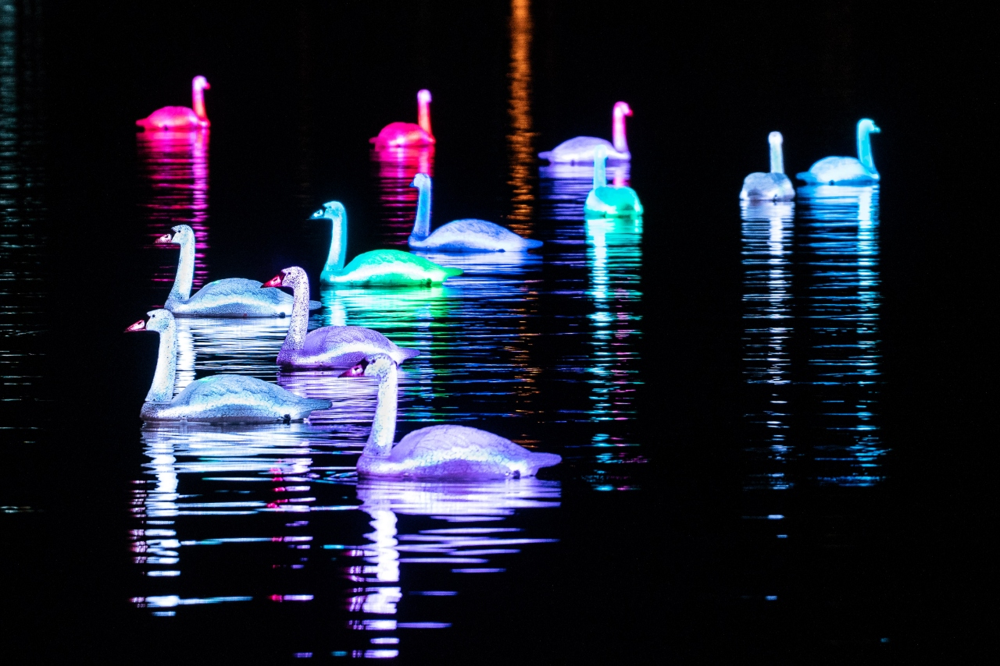
10th edition of «Live on Ice»  For the tenth time, the internationally renowned light and event artist Gerry Hofstetter will bring a romantic winter atmosphere to the city of Lucerne. The Christmas illuminated Europaplatz around the "Live on Ice" ice rink invites you to skate and enjoy from 25 November 2021 to 2 January 2022.  www.luzern.com/liveonice | 