11 tips for summer holidays in Ticino
Enjoyable experiences close to nature in the Italian-speaking area of Switzerland
Beyond the Gotthard Pass lies Southern Europe. With each advancing kilometre, the air feels warmer, the hills become greener and the landscape slowly alters from coniferous alpine forests to Mediterranean palms. Anyone who’s ever taken this route southwards knows the holiday feeling that overcomes you the moment you cross the southern side of the Alps and arrive in Ticino. From 6 June, all leisure facilities and tourist companies are able to reopen – meaning there’s nothing more standing in the way of your enjoying varied holidays in Switzerland’s ‘sun lounge’. Let us give you eleven tips to make sure there’s not a dull moment during your summer holidays in Ticino.
Cool off in a secluded bathing area
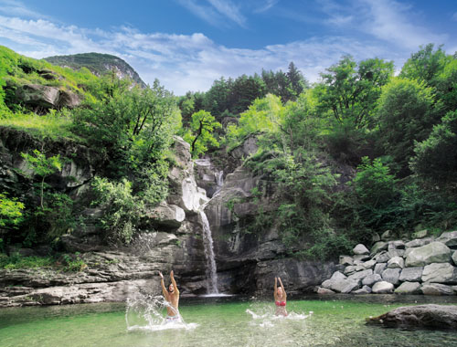
Water plays a huge role in Ticino. Two lakes with over 160 km of coastline, breathtaking waterfalls and idyllic mountain lakes shape the landscape of the Italian-speaking part of Switzerland and give Ticino its natural charm. The region’s rivers hold a particular fascination to anyone in the area – the emerald-green or turquoise crystal-clear water finds its way through the eroded rocky landscape of the unspoilt valleys and is particularly inviting on hot summer days. The Maggia and Verzasca are the most well-known for their bathing spots, but the watercourses of the Ticino, Melezza, Isorno or Breggia are also dotted with lots of hidden bathing areas and numerous natural water pools and small beach areas with the very finest sand. Ticino is rich with places to cool off in practically deserted areas, ideal after a walk or cycling tour or simply just to enjoy the summer sun and refresh your senses and strength every now and again surrounded by stunning nature. ticino.ch/waters
Il grotto ticinese – the culinary tradition of the Italian-speaking area of Switzerland
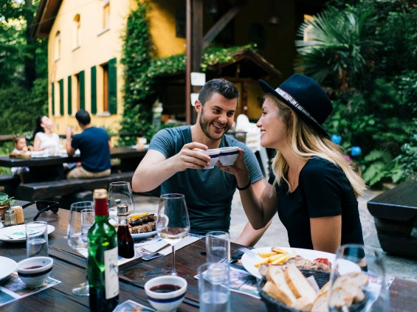
If you’ve never sat on a stone bench in the shade of a tree with a tazzin in your hand and a steaming hot plate of polenta sat on the table in front of you – in short, if you’ve never been to a grotto before – well, you need to do something about it right away. And no excuses: you’ve had since 11 May 2020 to do so! These traditional restaurants, which are as typical for Ticino as the sun all throughout the summer, serve authentic local dishes in unbeatable surroundings. The constructions themselves were originally our forefathers’ ‘refrigerators’ or larders, keeping food such as sausages, cheese and wine at just the right temperature during the summer heat – in fact, the temperature in a grotto remains constant the whole year round. Over time, these stone caves have been turned into rustic restaurants serving authentic Ticino specialities and local products to guests seated at tables and benches made out of granite under ancient trees. ticino.ch/grotto

Food & Wine Tour – new to Locarno and Bellinzona
Discovering a region’s culinary heritage is truly one of the greatest pleasures when travelling. After Lugano, the region of Ticino is also adding a new food & wine tour in Bellinzona and Locarno to its programme starting 6 June 2020. Led by a local guide, the 3½-hour tour takes visitors around the historic city centres. In addition to learning about the towns, participants stop off at different charming restaurants and bars to taste typical Ticino specialities such as regional cheeses, aromatic salametti, risotto or polenta. These delicious bites are accompanied by local wines such as Ticino merlot and by interesting stories about the different places in the town. Of course, the whole thing is rounded off with a sweet finish, meaning the walking tour is also a kind of tasting menu with different courses. The tour can be booked year-round on request, and is also available as a vegetarian/vegan option. ticino.ch/foodwinetour
Cantine Aperte - Day of the Open Wine Cellars in Ticino this year in August
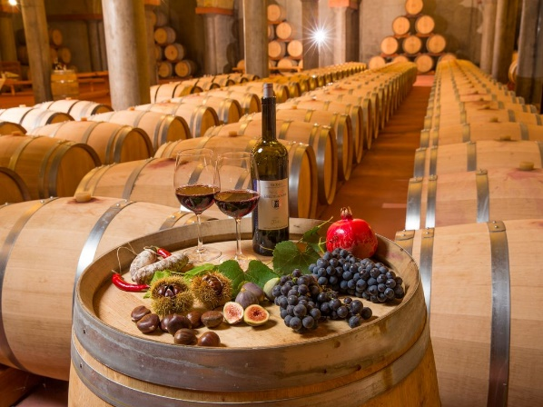
For more than 20 years, at Whitsun, around 80 Ticino winemakers have been opening their doors at the Open Wine Cellar Day (Cantine Aperte), which was not possible this year. But to the delight of Ticino summer guests, the weekend dedicated to wine takes place on 29th and 30th August 2020. The Merlot wines from Ticino have long ceased to be an insider secret. The southern Swiss climate is perfectly suitable for winegrowing. Passionate winemakers use this locality to create fine wines which need not fear international comparison. Furthermore, numerous wine cellars are also architectural gems located amidst idyllic vineyards. Both days of the Open Wine Cellars (Cantine Aperte) are a great opportunity for wine lovers to view the cellars and vineyards in Switzerland’s sunny basin, to talk to the vintners themselves and to taste the wine directly on site. Apart from wine tasting, many vineyards also offer lunch and dinner with local products, entertainment, music, exhibitions and cultural events. www.ticinowine.ch / ticino.ch/cantineaperte

New thematic route on the Monte Ceneri
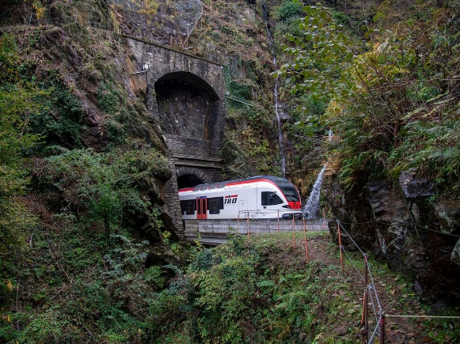
A new thematic route completed in the spring of 2020 pays homage to the importance of the Monte Ceneri in travelling from the north to the south. Whereas the Ceneri Base Tunnel (CBT) is set to speed rail travellers from north to south by the end of 2020, there is already an enjoyable route walkers can take over the monte in the Italian-speaking area of Switzerland. The 7-km Via del Ceneri starts on the Magadino Plain at the station in Cadenazzo and leads up and over the Ceneri Pass to the new Piazza Ticino. This historic pathway has seen numerous walkers, pilgrims, armies and tradespeople make their way over the Alps through the centuries. Information panels along the route provide walkers with facts and stories, as well as cultural tips and attractions, about the historical life in the region. This includes a restored mill, a roccolo (stone tower used in bird hunting), a radio museum, churches and chapels, as well as the symbolic totem on the Piazza Ticino made from the very stone taken from the construction of the AlpTransit tunnels through the Gotthard and Ceneri Tunnels. With a difference in altitude of just 420 metres, the walk is ideal for families and the illustrated panels are both educational and fun for the little ones. At the Piazza Ticino, there is also a sort of museum consisting of a gallery of images with informative panels showing the history of mobility on the Monte Ceneri over the centuries (from 1750 to 2050). ticino.ch/hike103
New Monte Tamaro MTB trail near Lugano
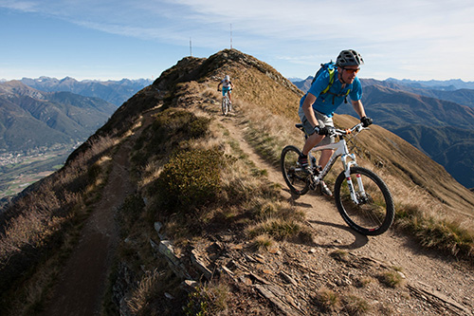
For biking fans, there’s a great new MTB trail on the Monte Tamaro in the Lugano region. The 32-km Monte Tamaro Bike No. 362 trail offers stunning views over Lake Lugano and Lake Maggiore and is a technically challenging route. From 6 June 2020, bikers are taken up to the Alpe Foppa by cable car, only to be met with an immediate steep ascent on the first unsurfaced section. After climbing some 330 metres, a stop on the Capanna Tamaro provides a 360-degree panoramic view of Ticino’s lakes and mountain landscape. It’s the ideal spot for getting ready for the long, technically challenging 9-km single trail downhill leading down into the Malcantone region onto Bedano. From here, the route leads back to Riviera through small Ticino villages and to the cable car station once more. With a total ascent of 756 metres and 1,811 metres descent, the 3½-hour tour is not to be missed. ticino.ch/tamarobike

130 years old and going strong: two rack railways celebrate an anniversary this year
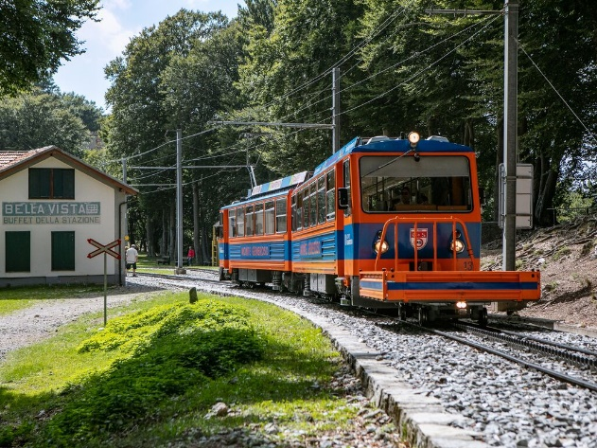
The Monte Generoso is, at an altitude of 1,704 m, one of the most popular mountain outlooks in Ticino with its stunning views over the lake scenery, the town of Lugano, the Po Plain and the mountains from the Apennines to the Gotthard Massif and the Bernina Range. The nostalgic rack railway, which has been transporting guests from Capolago on Lake Lugano up to the summit since 1890, is one of the oldest in the country. The 40-minute journey covers just under 10 kilometres and climbs some 1,000 metres in altitude. Upon arrival at the top, you are greeted by the Monte Generoso’s real emblem, the Fiore di Pietra building designed by star architect Mario Botta. But that’s not the only rack railway celebrating an anniversary this year... the Funicolare Monte San Salvatore, which has been transporting visitors 912 metres up to the local mountain near Lugano for the last 130 years, also has a birthday. When the weather is good, you can enjoy a wonderful 360-degree panorama from the Bernese and Pennine Alps to the Po Plain with the city and Lake of Lugano at your feet. According to local legend, Jesus made a short stop-off on top of the 912-metre high peak on his way up to heaven to take one final look at the beauty of the Earth. At least, that’s how the locals say the mountain got its name of Monte San Salvatore: the Mount of the Holy Saviour. In addition to the panoramic view, we can also recommend investigating one of our numerous walking paths and taking a quick look at the events calendar for the two mountain outlooks as there are a few surprises in store in the coming weeks. www.montegeneroso.ch, www.montesansalvatore.ch
Parco Scherrer: A museum in the Garden of Eden
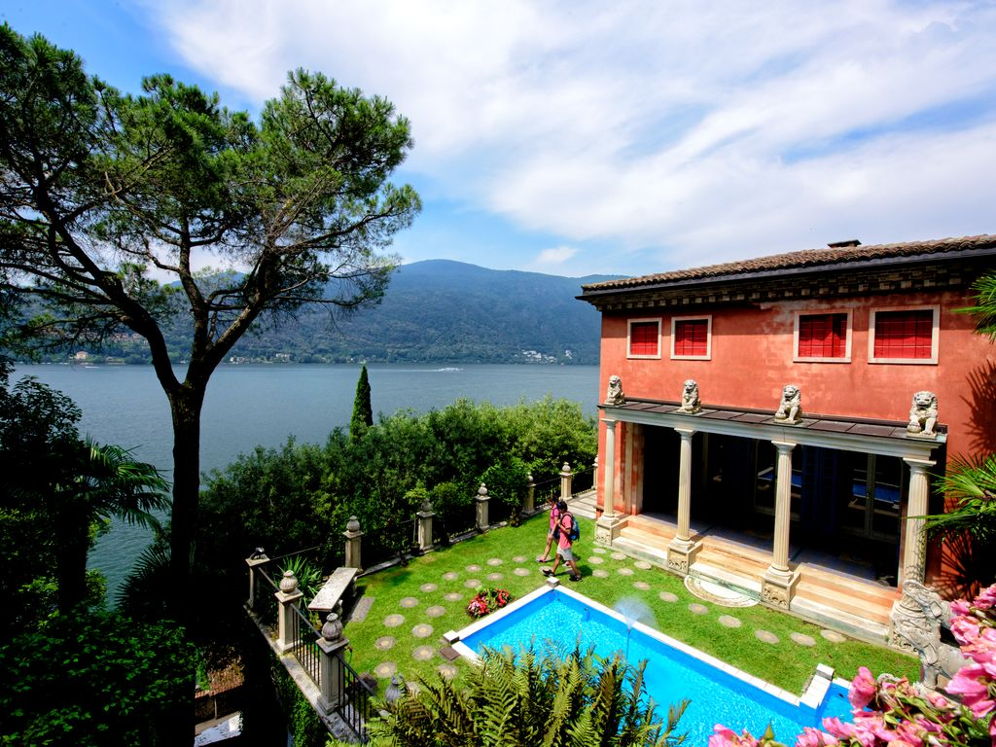
For many, Morcote on Lake Lugano is the most beautiful village in Ticino. It clings to the lee side of Monte Arbostora and therefore enjoys a very mild climate even in winter. Herrmann Arthur Scherrer (1881–1956) was a textile merchant who saw a lot of the world and developed a special passion for the art and culture of the Orient. By purchasing land piece-by-piece on a steep slope north of Morcote, he realised his dream of creating a Garden of Eden that went on to become one of the village’s greatest attractions. Under Scherrer’s artistic direction, what had once been a tangle of vineyards and scrubland became a sub-tropical park of cypress trees, cedars, palm trees and bamboo groves. In order to create the perfect surroundings for the artworks and sculptures that he had collected on his travels, Scherrer constructed lots of small classical and far-eastern style buildings. In addition to a copy of the Erechtheum – a small, Greek temple with female figures as columns – there is also a Siamese tea house, an Arabian palace, a small sun temple and even an Egyptian mausoleum. Parco Scherrer has been open to the public since the 1970s allowing visitors the opportunity to enjoy a little fantasy of paradise. Parco Scherrer is just one of the Mediterranean gardens in Ticino that will be open to the public again from 6 June 2020. Around Lake Lugano and Lake Maggiore, a number of parks and gardens invite visitors on a botanical world tour: Thanks to the mild climate, you can see plants from all continents. ticino.ch/gardens
Hiking past mountain lakes in the Piora valley
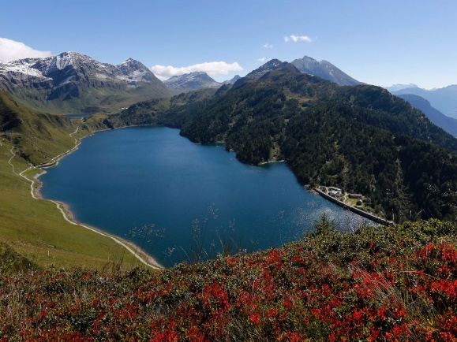
Shall we go the mountains or the lake? It’s not a question you hear in this part of the Ticino, for the idyllic Ritom-Piora region in the Leventina offers both. The path up to this alpine paradise is steep, but easily accomplished in 15 minutes by opting for the funicular railway, which dates from 1921. The trip from Piotta village to the summit terminus – an elevation gain of 786 metres – features a gradient of 87.8 percent, making the funicular one of the world’s steepest. A few minutes’ walk from the summit terminus at alt. 1794 metres is Lake Ritom, a reservoir with, behind it, a fabulous landscape of lakes and mountains. It’s a pleasant ascent to the Pizzo Föisc (alt. 2208 m) and the Rifugio Föisc self-catering mountain hut. After a well-earned rest, the path leads back to Lake Ritom, the canton’s largest mountain lake. Following the left-hand shore you arrive at the fork leading to Lake Tom, noted for its delightful white sandy beach. You then continue to Lake Cadagno, the third of the Piora lakes, where you traverse the Alpe di Piora, one of the largest alpages in the Ticino and a protected natural reserve. It’s possible to stay at the nearby Cadagno mountain hut, but otherwise the path leads back to the summit terminus of the Ritom funicular railway and the end of this excursion. Piotta, your setting off point in the valley, can be reached by PostBus from Airolo or Faido. Length: 15.55 kilometres, duration: 5½ hours, difficulty: medium, ticino.ch/hike2, ticino.ch/pioravalley
Sentiero Cristallina: 3 days in the Ticino Alps
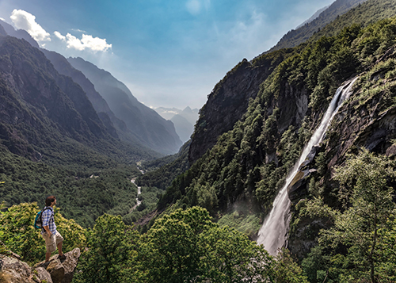
We’re delighted to say that Ticino’s mountain huts have also reopened their doors. So we invite you to rediscover nature – after all, what could be better than hiking through Alpine heights and tranquil valleys? The 42-kilometre Sentiero Cristallina is one of the most stunning mountain hikes in the whole of Switzerland. Starting in Bignasco in the Maggia Valley, it runs past the Cristallina Hut, into the Bedretto Valley and finally onto Airolo. The first day leads through the magical natural backdrop of the Val Bavona – Ticino’s wildest area. Following the river, the path runs by a 108-metre waterfall in Foroglio and 12 hamlets with typical Ticino stone houses and onto San Carlo. The second day starts with an ascent up to the Robièi reservoir with a view over the ice of the Basodino Glacier and onto the Capanna Cristallina. The mountain hike on the sunny side of the Bedretto Valley finally takes the hiker on the third day through the upland moor landscapes affording beautiful views to the Gotthard Massif. ticino.ch/hike203

Ticino – a climbing paradise on the southern side of the Alps
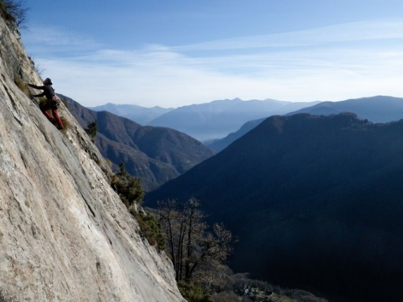
With more than 80 developed climbing areas and a particularly favourable climate on the rocks, Ticino is known as a real paradise for hobby climbers who can push themselves to their limits on the granite, gneiss or dolomitic rock faces. From the Maggia Valley to the Valle Onsernone, from the Valle Verzasca and the Riviera region all the way to Leventina, and from the Blenio Valley and the Bedretto Valley – there are plenty of accessible climbing walls for everyone. The first and most important area in Sottoceneri rock massif is the Denti della Vecchia, an impressive ridge of peaks visible from Lugano and forming the border with Italy. As far back as the start of the 1930s, famous mountaineer Emilio Comici climbed on the “old woman’s teeth”, as the name translates from the Italian. Nowadays climbers can enjoy a range of 123 different routes in various degrees of difficulty. The most famous climbing region in Ticino from an international point of view is the Ponte Brolla. Its sunny location and ease of access at the entry to the Maggia Valley have made it one of the leading reference points on the climbing scene. And if you’re after a real adrenaline kick, look no further than the climbing wall on the Diga di Luzzone – at 160 metres, it’s the longest artificial climbing route anywhere on the planet. The five pitches consist of around 650 artificial holds and bolts. The difficulty of this vertical concrete wall gradually increases until the final section is even slightly overhanging, making climbing it a truly special experience. ticino.ch/climbing
For more information:
TICINO TURISMO
Jutta Ulrich, Head of Communications
Tel: +41 91 821 53 34, E-mail: jutta.ulrich@ticino.ch
Via C. Ghiringhelli 7, CH – 6500 Bellinzona

