Crans-Montana, a paradise for mountain lovers
Winter times at Crans-Montana 2
a. A paradise for skiers 2
b. A variety of winter activities 4
i. Grandeur Nature 4
ii. Brand new ice skating rink 4
ii. Magical walk on the white golf course 4
d. Events 4
iii. Crans-Montana Audi FIS Ladies’ Alpine Skiing World Cup 4
iv. Caprices Festival 4
e. Our advantages 5
i. Shopping 5
ii. Powdair 5
iii. Lifestyle 5
f. The Crans Ambassador 5***** Hotel 5

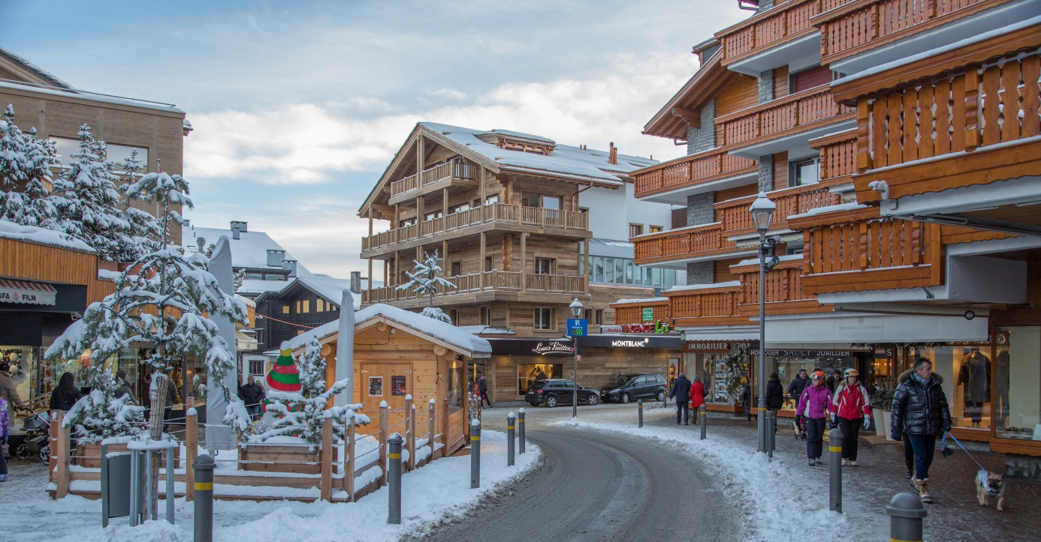

Winter times at Crans-Montana
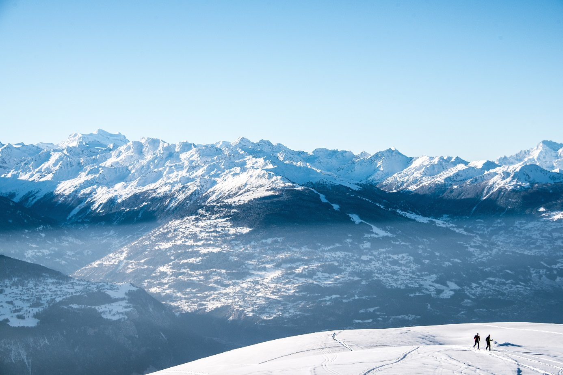

a. A paradise for skiers
With over 100 kilometers of slopes facing south, Crans-Montana ski resort will definitely bring sunshine to your holidays.
We offer an alternative for everyone, whether you’re a beginner or a hardcore skier. Come and challenge yourself in our Olympic-standard half pipe, explore the wilderness of the Aminona area or go for a dog-sledge ride on the Plaine-Morte glacier, the mountain is yours!
Crans-Montana ski resort is pleased to announce novelties for the 2017/2018 season such as:
- A series of new secured ski-touring trails
- A sledge track (depending on snow conditions)
- A series of night skiing evenings
- New weekly events on the slopes
- Grand events featuring major DJs at Cry d’Er Club d’Altitude
Need a break? Cheese raclette at the Cabane des Taules, pizza at the family friendly Arnouva restaurant or a bistronomic experience on Cry d’Er’s panoramic terrace followed by a wild evening in the altitude club – with over 20 restaurants and cabins to choose from, we trust you will not go hungry or thirsty.
Cry d’Er Club d’Altitude & restaurants
Ever clubbed at 2220m above sea level? Cry d'Er Club d'Altitude is the new hot spot you should not miss when in Crans-Montana. The complex, encompassing a self-service area, a " bistronomic" restaurant and a night-club, offers a unique experience and breathtaking scenery attracting world renown DJ's such as M.A.N.D.Y., The Martinez Brothers and Matthew Jonson.
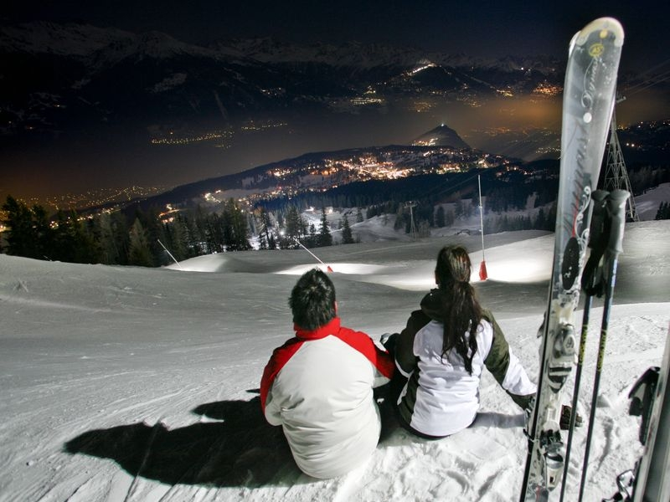
Night skiing
A fairytale-like environment for a unique experience; night skiing will change your perspective and heighten sensations. This winter, you will be able to experience skiing under the stars every week! Gather your family and friends for this unique moment.
Free Access to Arnouva
We offer free access to the Montana-Arnouva gondola, allowing parents to attend their children’s first ski classes, and permitting pedestrians to get a breath of fresh air and a much appreciated sunbath while sipping a warm beverage on the Arnouva terrace.
Snowpark
Crans-Montana offers two snowparks for different levels located near the Cry d’Er area; the easy snowpark will allow beginners to train safely, while the regular snowpark and its Olympic-standard half pipe will welcome the experienced riders.

b. A variety of winter activities

i. Grandeur Nature
Sustainable tourism returns to Crans-Montana this winter with a comprehensive programme of activities under the “Grandeur Nature” label. The Aminona region is a paradise for those who love the great outdoors, with panoramic views of the Valais Alps that simply take your breath away. Take a look at our weekly program of free guided activities, including sunrise snowshoe, a children’s treasure hunt and a forest walk with husky dogs.
https://www.crans-montana.ch/en/activities_/Aminona-Grandeur-Nature-393/?hiver&idcmt=Partenaire_Activite_82dcede7749f91f6f5b97bcf543fc567
Image: https://crans-montana.wikipixel.com/c/3mUSvC

ii. Brand new ice skating rink
We are very proud of our brand new 3340m² indoor and outdoor ice skating rink. Open every day, families share the fun and excitement of skating. Disco on ice every Friday, and shows make the winter programme. Curling is a very fun sport to discover. Friends and families can book an initiation session. Available every evening from 4 people.

Image: https://crans-montana.wikipixel.com/c/JUDSXc

ii. Magical walk on the white golf course

In winter, the golf course is covered by a beautiful white coat of snow and offers lots of activities for all tastes. The Severiano Ballesteros and Jack Nicklaus courses are also very popular for walking. They’re accessible to everyone, and several circuits which can be completed on foot or on snowshoes offer the chance to enjoy wonderful views and take a break on one of the sunny terraces.
Snow Island, Bibi’s home quarters, invites families to take part in different activities, games and entertainment. This is also where beginners can try skiing thanks to the very gentle slope and magic carpet which will take them back to the top of the run, or you can hurtle down the snow-tubing downhill at top speed. 7 km of cross country ski tracks are also available for the sporty, and the more daring can explore this wonderful area by fatbike.
Image https://crans-montana.wikipixel.com/c/d3x0t5

d. Events

iii. Crans-Montana Audi FIS Ladies’ Alpine Skiing World Cup
From 3rd to 4th March 2018, the world’s top female skiers will gather in Crans-Montana to
test their skills on the challenging Mont Lachaux piste.

iv. Caprices Festival
The fifteenth edition of the Caprices Festival will take place from 5th to 8th April 2018. As in previous years, aficionados of the Modernity (MDRNTY) events can party to the sounds of the best DJs on the planet in an unbelievable setting at 2,200m above sea level, right in the middle of the ski area.

e. Our advantages

i. Shopping
Switzerland Tourism describes Crans-Montana as the “Shopping Paradise of the Swiss Alps”, with more than 190 shops and boutiques, including world top luxury brands as well the best Switzerland and our region can offer: Swiss watches, Valais wines, sport equipment, chocolate. Crans-Montana now hosts Switzerland’s best chocolate maker, David Pasquiet, www.instant-chocolat.ch awarded “Swiss Chocolate Master 2013”.

ii. Powdair
If you’re a ski fan from UK or Benelux, Airline POWDAIR is the best news for winter 17-18. During all the season fly from 6 destinations to Sion airport. The slopes are now less than 3 hours away from London. www.powdair.ski

iii. Lifestyle
There is a huge choice for entertaining young and old alike: 3D cinema theatre, 4 lane American bowling, library and games library, pool room, bridge and chess club, tennis and squash clubs, and the Crans-Montana Casino! Slot machines, gaming tables, and a bar and restaurant, open year round

f. The Crans Ambassador 5***** Hotel

The Crans Ambassador, Luxury Sport Resort, 5* Hotel and latest member of the Victoria Jungfrau Collection immerses you in the heart of the Swiss Alps. As soon as guests step into the hotel, a 180° view of Europe’s highest, most stunning peaks takes their breath away.
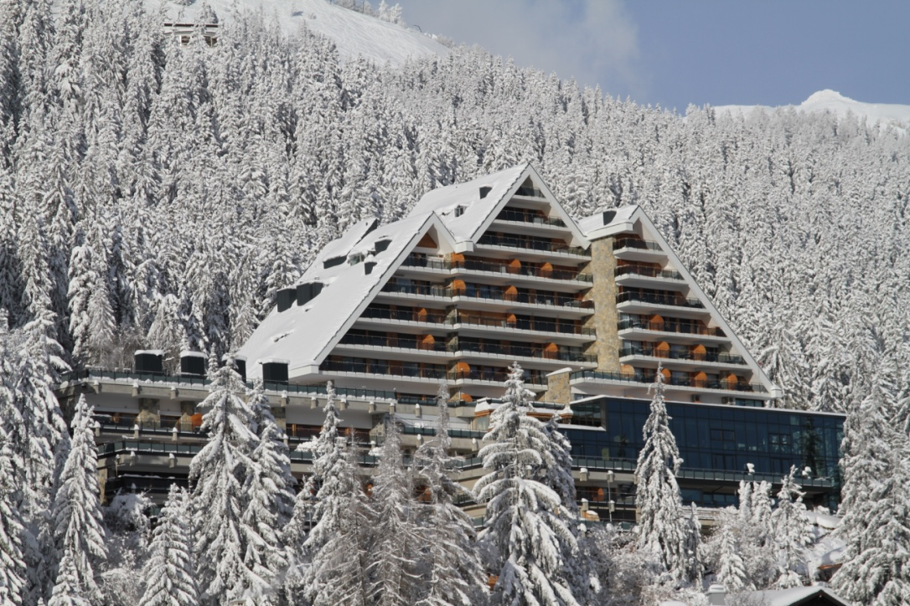
With 56 rooms and suites, the CRANS AMBASSASOR is open for the winter and summer season. The Crans Ambassador is highly kids-friendly. The hotel has a Kids-club, kinds menus and many other possibilities to spend holidays as a family.
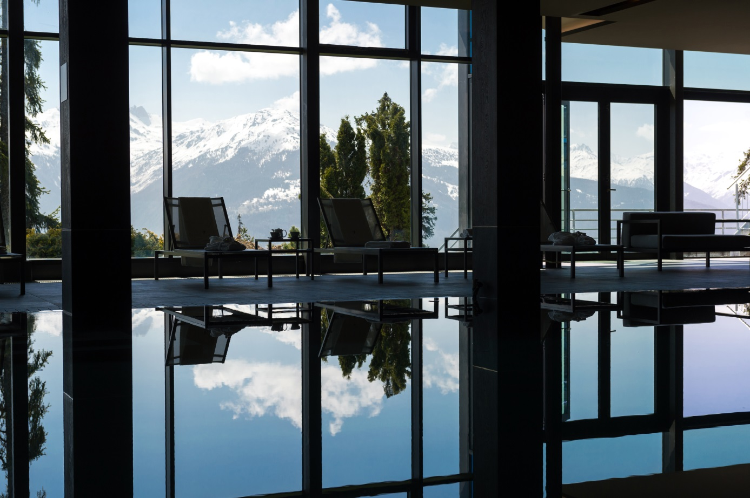
The Spa, which is dedicated to the devotees of sport and wellbeing. Occupying 1300 m2 and centered on a 17 m indoor pool, as well as spaces devoted to relaxation, such as sauna, hammam and treatment cabines.
The CRANS AMBASSADOR offers a large possibility of restauration with:
« La Table » a gastronomic restaurant where, the Chef William Weiss brings his highly personal take on cuisine to the Crans Ambassador.
Without forgetting the New Year’s Eve with live music, DJ and a lovely 5 course dinner at the restaurant « La Table ».
« Le bar Lounge » with an amazing 180° view offers a wide range of cocktails and aperitifs. At the weekends a DJ « heats » the Bar before and after dinner.
« Le Carnotzet » a restaurant serving typical Swiss cheese specialities invites the guests sharing local cheese products of Alpine products.
« La Terrasse Valaisanne « one of the most exceptional panoramic views of the Alps, becomes an Open air restaurant, proposing an Oyster bar, Raclette as well as roasted on a spit meat specialities, are served from midday until 5 pm. A nice place to come for the after-ski in a delightful setting.

